Drake’s Recommended BASIC Armor Purchases

Included within this document is the result of research detailing the “best” armor to purchase for a new fighter. The term “best” for this purpose is defined as:

- Inexpensive
- Functional
- Typically delivered in a timely fashion
- Not unattractive

These are only my opinions and observations. I have never met or spoken to the armorers who manufacture this equipment. I am solely referencing items I have seen from these makers, as well as positive feedback from sources such as www.armourarchive.org. If price is less of a factor, please contact me and I can advise you on higher quality/price purchases if that is your preference.

The armor pieces do not include leather for knee articulations, kidney belt, vambraces, gorget and optional chest/shoulder protection. Luckily, we have an excellent local source for leather in The Leather Factory. Additionally, we also are fortunate to have a number of local individuals who will assist new fighters in the assembly of these parts (along with the aforementioned leather) into a very functional suit of SCA chivalric combat armor.

It appears that, with the below pricing, a suit of very functional armor can be assembled for under $200 (including shield and sword baskets). Once again, this does not include material for a shield, leather, buckles and rivets, dye, rattan, duct and strapping tape, padding, etc…

Good luck!

Drake

Helms

http://www.ashcraftbaker.com/12g%20Spangen%20lift.htm
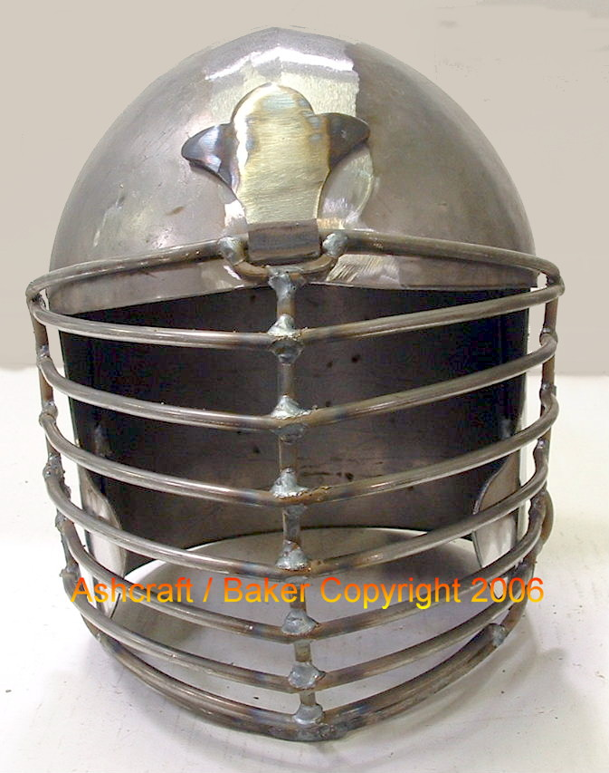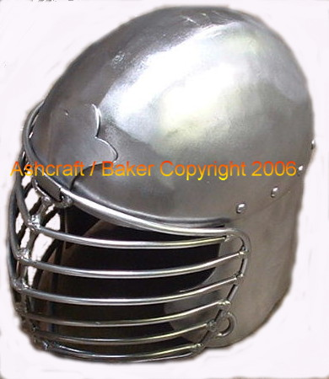

$105-$115

http://www.ashcraftbaker.com/Conical%20lift.htm 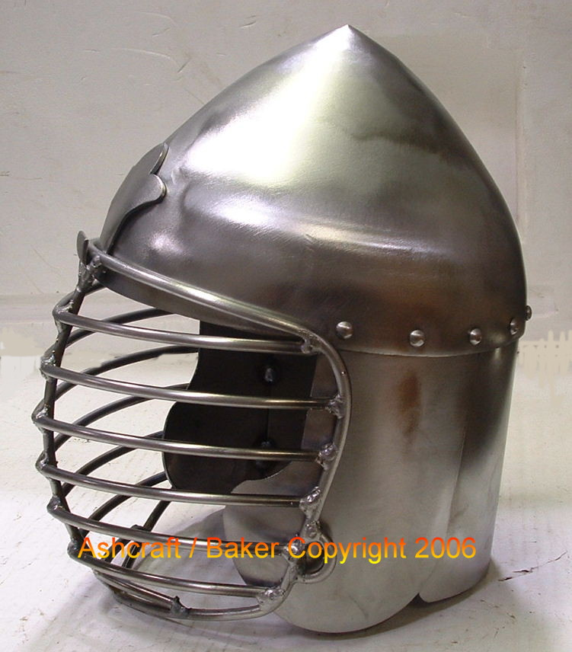
$120-$135

(This company is Texas based)

http://armourandcastings.com/catalog/index.php?cPath=32

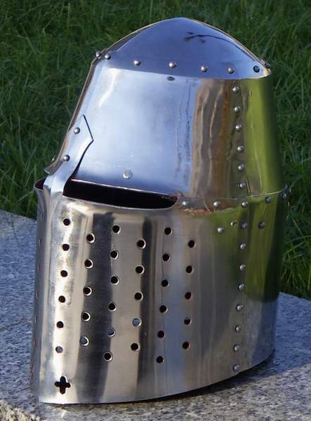
$100

http://www.ironmongerarmory.com/index.php?p=helms

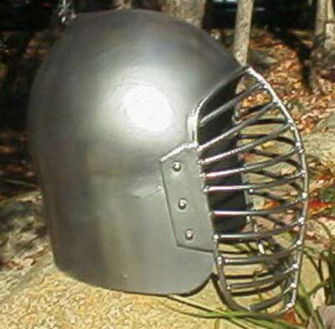
$120

http://www.illusionarmoring.com/
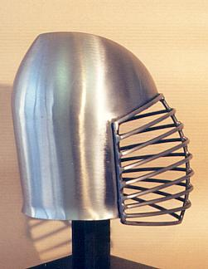
$85-$128 (mild or stainless) (some delivery problems)

Hilts

http://houseasgard.com/BaldarBlunts/#cuphilt
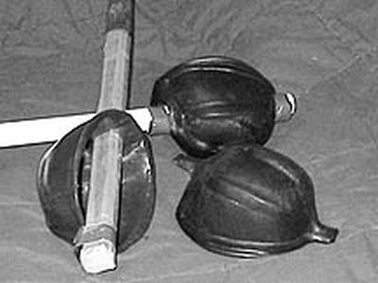
$30

Elbows

http://spiers-saddlery.stores.yahoo.net/gofael.html

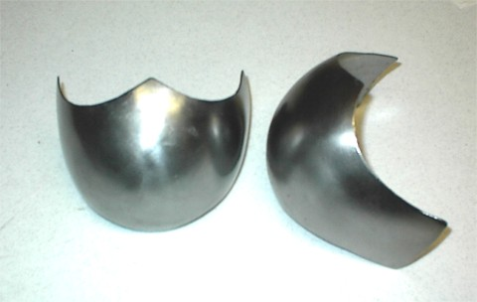

$15 (This company is Texas based)

Knees

http://spiers-saddlery.stores.yahoo.net/gofaknco.html

$15 (This company is Texas based)

Shield Basket

http://www.ashcraftbaker.com/shield%20hilts.htm
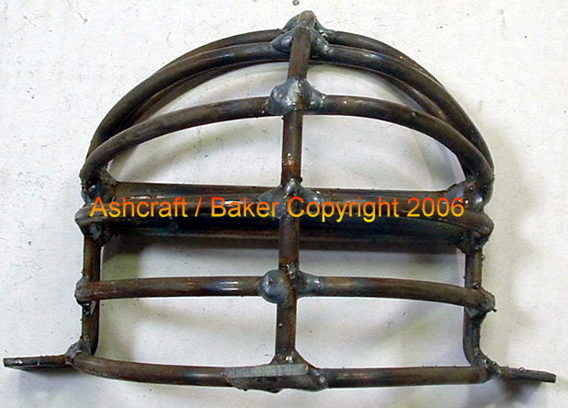
$15 (not beautiful but great value for the price) (This company is Texas based)

