Making a Khaleegy Thobe
These are the beautiful big dresses used for a woman's social dance in the Arabic Gulf. They are very loose and have embroidered front panels. Often the seams are also decorated. The backs are plainer.
A realistic thobe can be made from a sari. With careful cutting the decorated portion can be used for the front panel.
To see how they turn out click here
In laying out the pieces the two sleeves take 2m of 1.1m fabric. If using a single strip for the front and back another 3.5m is required. The bottom side panels can be fitted on the same piece to get the whole thobe out of 5.5m of fabric. Alternatively you can cut just the back out of the main fabric reducing the requirements to 3.8m plus the front panel. In this case the front and back panels are seamed together.
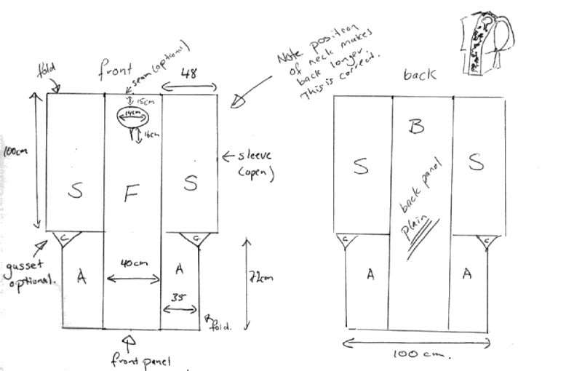 | S - sleeve 2 @ 2m x ..48  F - Front panel 1.75 x .4  B - Back panel 1.75 x .4  or combined into 3.5 x 4  A - side panels 2 @ .7 x .75  (all measurements are approximate)  Layout:  S F & B  S A A  or  S B  S A A  plus front panel
To make up the thobe:
Cut out:
1x front panel (F) 40cm x 175cm
1x back panel (B) 40cm x 175cm
(or 1x combined centre panel 40cm x 350cm and one fancy front panel)
2 x sleeves (S) 200cm x 50cm
2 x side panel (A) 75cm x 70cm
2 x gusset (G) - optional
Making up:
Sew the front to the back at the top. (Alternatively sew the "fancy" panel in this position over the extra long centre panel)
Cut out the neck hole from the front panel – this is a small circle and a 15cm slit. The top of the neck hole should be about 15cm down from the top. Face as required.
Fold the sleeves in half. Align the fold with the top seam of the front and back panels.
Sew the sleeves to the front & back panels.
Fold the side panels in half.
Sew the side panels to the sleeve above and front/back panel. (Add gussets if desired)
You should have a large rectangular garment with two large armholes of about a metre, open at the bottom and when you put your head through the hole in the front the front should be shorter than the back.
Hem edges.
Decorate the front panel with sequins, beading, couching etc. Optionally decorate seams. Add a little decoration to the rest of the dress as desired.

Return to "How To" page
Return to www.raqs.co.nz

