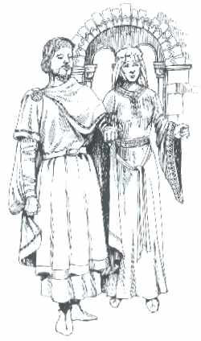

The Shire of Rosenfeld

Invites you to share in a Day in the SCA,

celebrate A.S. XXXXIII, on May 18,

At the Pavilion in Longview’s McWhorter Park.

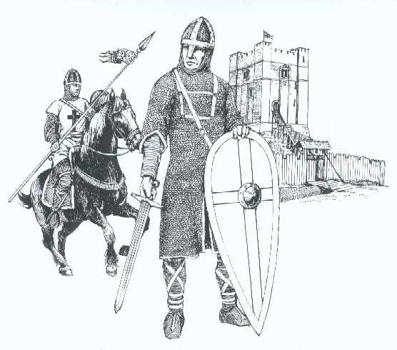
Bring your medieval pavilions and

Your Art projects to share with others,

Don your Fighting gear,


Share with us your Period Games.

Set-up begins at 8 am

Fighting and other activities, begin at 10 am
Bring your feastgear and a dish to share.
Feasting begins at 4pm
6pm Closes

Steward ~ Lord Aradonn of FalconRose Keep
Lordfalconrose@gmail.com 903-469-3420, 903-469-6119

Potluck coordinator ~ Lady Eithne
eithnethehealer@gmail.com 903-469-3420

Map Reference
http://maps.google.com/maps?hl=en&client=firefox-a&ie=UTF-8&q=mcwhorter+park+&near=Longview,+TX&fb=1&cid=32522000,-94790410,2515976605503114984&li=lmd&z=14&t=m

