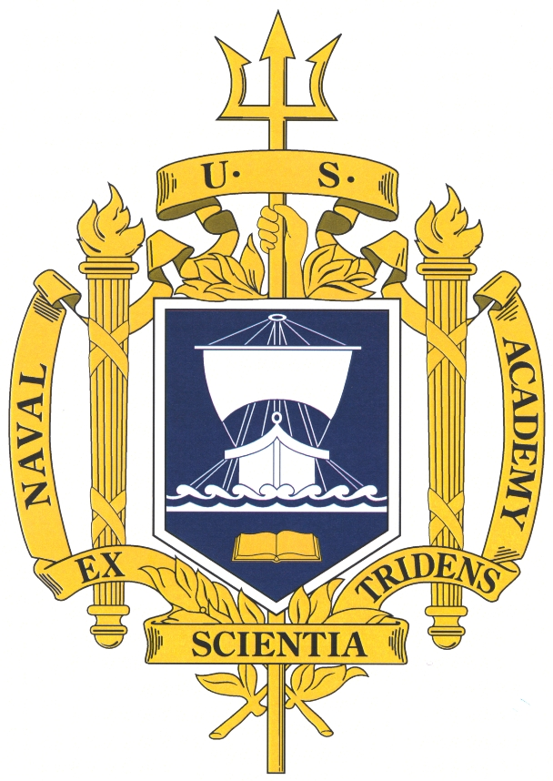

THE UNITED STATES NAVAL ACADEMY
MEN’S GLEE CLUB

The MEN’S GLEE CLUB is the most active of the Naval Academy’s musical organizations and has achieved national prominence as one of America’s premier men’s choral ensembles. Recent appearances on network television include The Kennedy Center Honors (CBS), The Today Show (NBC), The Early Show (CBS), Christmas in Washington (NBC and TNT), and Good Morning, America (ABC). The ensemble has been seen performing in San Diego’s Copley Symphony Hall, New York’s Avery Fisher Hall, and Washington’s Kennedy Center. It has performed extensively throughout the U.S. and abroad including Chile, Argentina, and multiple European tours with performances at St. Peters in the Vatican, cathedrals in Brussels, Wells, Winchester, Salisbury, and St. Paul’s in London. Performing masterpieces of choral-orchestral literature with many of the nation’s leading orchestras, the Men’s Glee Club’s most recent collaborations include Boston Pops Orchestra, Charlotte Symphony, Phoenix Symphony, Columbus Symphony, and Nashville Symphony. In addition to the Academy’s annually sold-out concerts of Handel’s Messiah with the Annapolis Symphony (often nationally and internationally broadcast), symphonic repertoire has included Orff’s Carmina Burana, Requiems by Brahms, Dvorak, Mozart, and Verdi, Haydn’s Creation, Beethoven’s Ninth Symphony, and Vaughan-Williams’ A Sea Symphony among many others. Recent notable appearances include the Inaugural Concert “We Are One” performed on the steps of the Lincoln Memorial for a live audience of over half a million and an internationally televised audience, the dedication ceremony of the National Pentagon Memorial, the Ronald Reagan Freedom Award, the Commissioning of the George H. W. Bush Aircraft Carrier (CVN-77), numerous concert tours, a performance with Chanticleer, and a newly released CD. It is with honor, pride and distinction that the Men’s Glee Club represents the United States, the Navy and Marine Corps, and the Naval Academy.

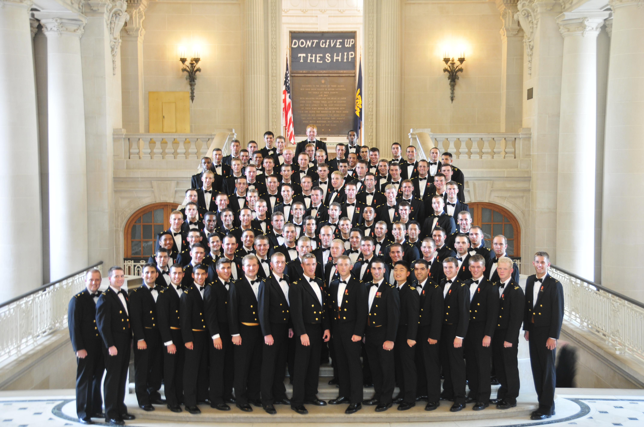

Additional information can by found by visiting our website at www.usna.edu/music

IN CONCERT
Saturday, March 17, 2012 at 5:00 p.m.
St. Martin’s Episcopal Church
717 Sage Road, Houston, TX 77056
FREE ADMISSION
Doors open at 4:30 p.m.

