Oyez, Oyez, Oyez!
This Wednesday at 5:00 PM
Room 307 in AB-IV (3rd Floor)
The Webb Society
Presents:
The 11th Texas Cavalry
&
Society for Creative Anachronism

Come and learn about the excitement of historical reenactments. Whether your historical interests are with Rome, the Middle Ages, the Renaissance, Feudal Japan, or the Civil War they will all be possible to almost relive.

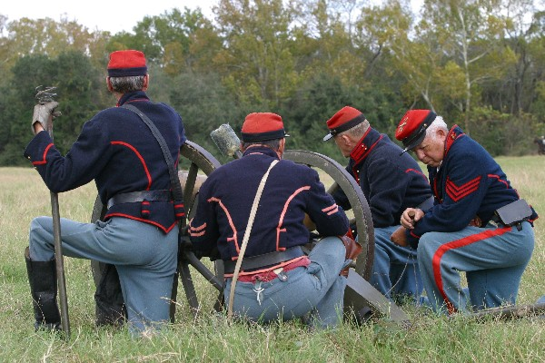
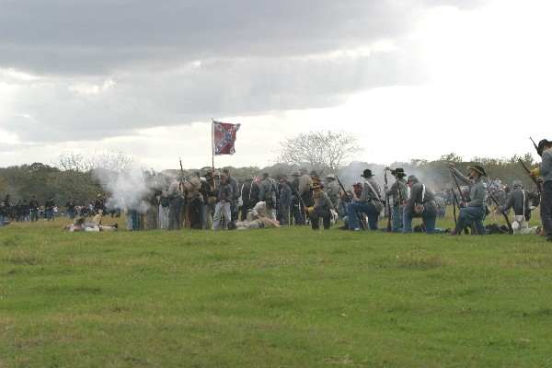
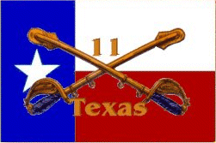
Feel the ground shake beneath your feet as you charge across a smoke laden Civil War battlefield with the 11th Texas Cavalry.

Visit the 11th Texas Cavalry at: http://11texascav.org/
************************************************************************
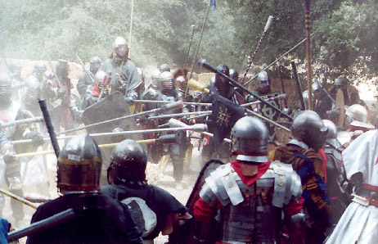
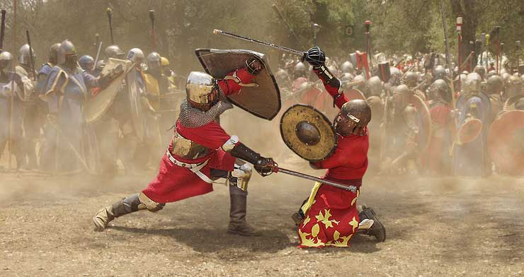
Or engage in full contact Medieval Battle with wooden rattan weapons while arrows, crossbow bolts, ballista bolts, and debris from trebuchets hail upon you. Join warriors from around the world who reenact with the SCA. Learn a wide array of historical Arts & sciences from brewing, costuming, court dancing, and much more. Put your talents to the test in competitions such as: equestrian, weapons throwing , chess, bardic, rapier fighting, and more.
Visit: http://www.youtube.com/watch?v=8vljdsfphks
http://users.ev1.net/~jacinth/ravensfort/ or www.sca.org

