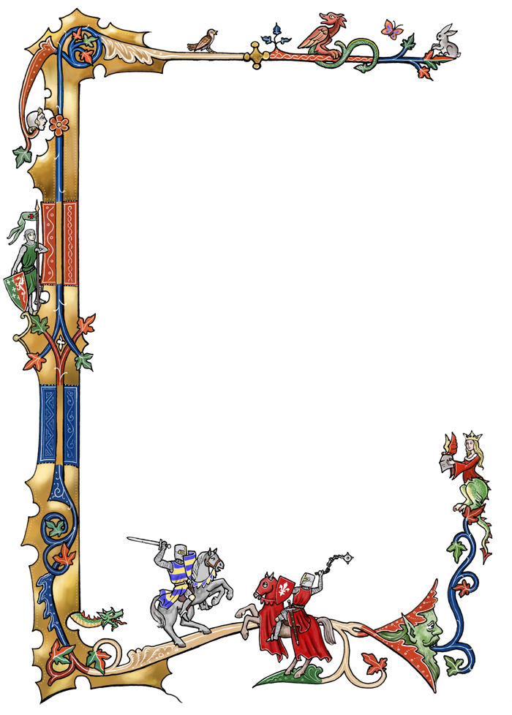

Arts & Sciences

Tournament of Champions

to be held at

Ansteorra 40th Year Celebration

Saturday, September 21, 2019

Format and Rules

Entry-Each group reserves the right to have an artisan of their choosing represent them at the Tournament of Champions.

Artisan-The chosen artisan may be the groups titled artisan or they may be an artisan chosen from their populace.  Once the artisan agrees to represent a group, said artisan may not represent another group for Tournament of Champions.

Format-The competition will be single item entry only.  Documentation is required, no theme.  This is a ‘bring your best piece’ competition.

Judging-The judges shall be Their Majesties (one vote combined), Their Highnesses (one vote combined), and a group of three (3) anonymous judges.  This number guarantees no ties and an overall winner being selected.

Prize-A generous prize basket will be provided to the winner.  We kindly request each group participating sponsor and provide a prize for a “best of” in any chosen arts or sciences field.